Appendix 10: The work of two journalistic groups in experiment 1

Case 1, Karen’s class, screen shot from a homepage produced by Danny and Mike

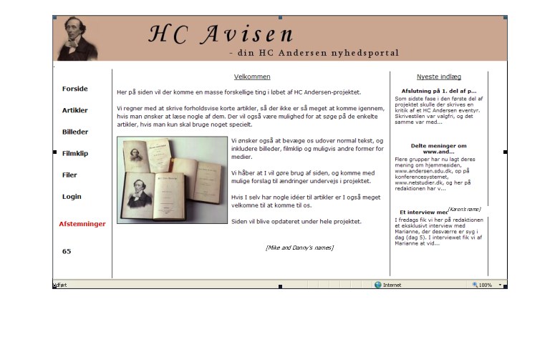

Case 3, Susanne’s class, copy of article by Anne and Ellen published in local paper

